# Chapter 4: System Analysis and Design

## **System Diagrams**

### User-Case Diagram

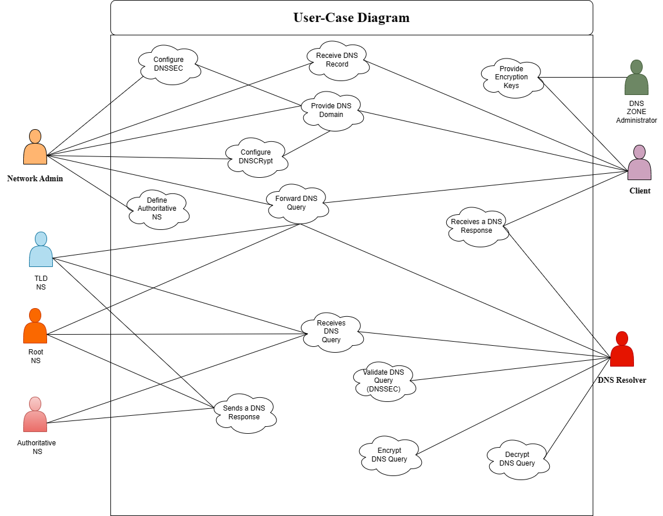

### Sequence Diagram

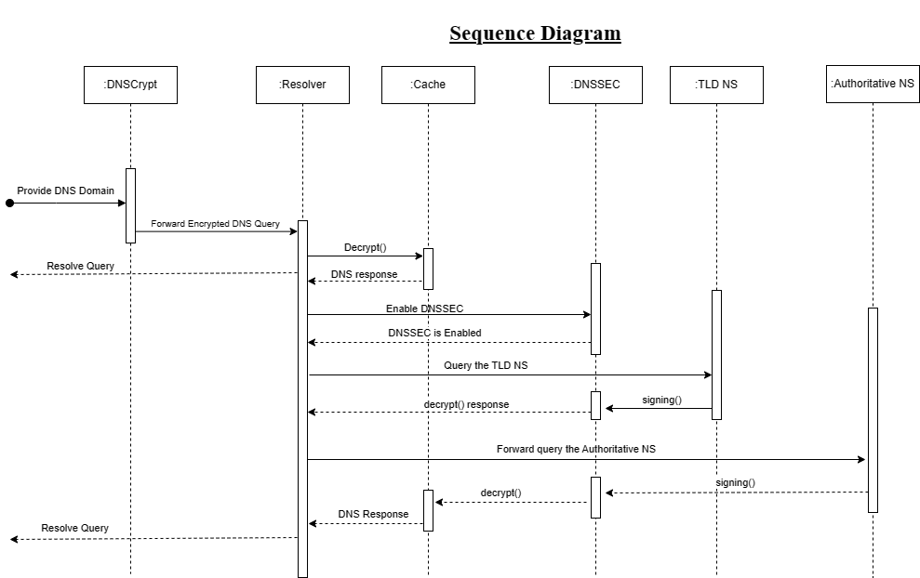

### Finite State Machine Diagrams

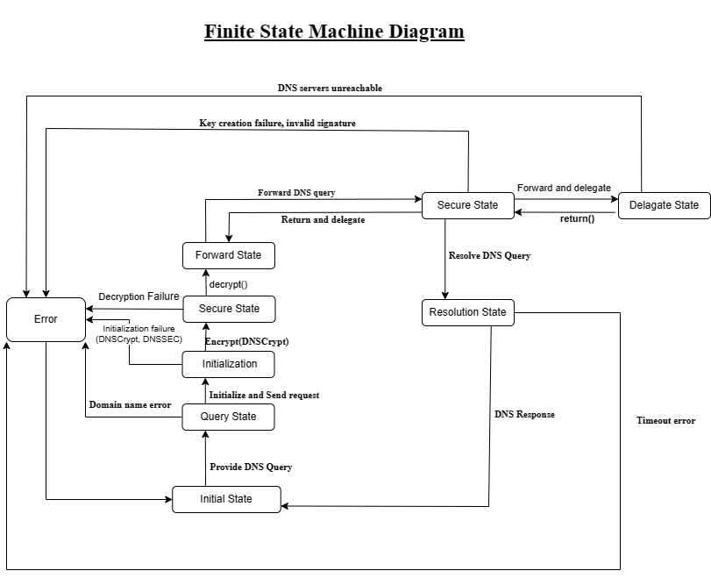

### System Flowchart

### Network Topology

### System Architecture

